Kids pick up on parents' stress, survey finds
By Sharon Jayson, USA TODAY
Tuesday, November 9, 2010

Parents may think they're shielding their kids from worry and stress, but a report to be released today by the American Psychological Association finds they don't do a very good job of hiding their stress from their children.
Ninety-one percent of 1,136 young people ages 8-17 surveyed cite ways they know parents are stressed, largely by their behavior.
MONEY: A major stressor this year
CHUBBIER CHILDREN: Show more signs of stress
"They're trying to protect their children from stress," says Norman Anderson, the association's CEO. "The message from the survey, unfortunately, is that children are able to see through that."
The online survey, conducted by Harris Interactive in August, shows:
•34% say parents yell.
•30% say parents argue with other people in the household.
•18% say parents are too busy or "don't have time for me."
Bob Carroll, 60, a Chicago father of two, says he deals with stress by watching TV, doing yardwork or something that lets him "zone out."
"I try to go on to something else so I don't take the stress out on other people. That's so counterproductive," he says. "I think what's happening with a lot of people is the stress is taking them over, and it's reflective in everything they do. They pour it out on everyone else."
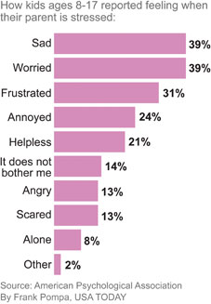
HOW KIDS FEEL

Annette Rodriguez, 40, a mother of two in New York City, says it's understandable that parents want to protect their children, but it's better to level with them about financial concerns, especially in a tough economy.
"Kids are not dumb," Rodriguez says. "They're smarter than we give them credit for. They know what's happening."
Experts agree, says Anderson, a clinical psychologist.
"It's actually better to talk with your kids about the fact that the parent is having challenges," he says. "The key message is 'We're going to address these difficulties and we'll be OK. We'll get through this.' "
Of the young people surveyed, 32% believe that their parent has been "really worried or stressed out about things" in the past month; just 6% responded "never."
Findings suggest, however, that adults are feeling fewer physical symptoms of stress (irritability, fatigue, anxiety) than four years ago. And the percentage of those reporting no such symptoms increased from 16% in 2007 to 24% this year.

